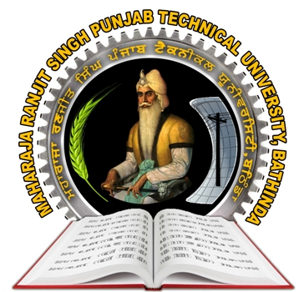
Maharaja Ranjit Singh Punjab Technical University
Dabwali Road, Bathinda-151001 (Punjab)
B.Sc. (Fashion Technology)

hodtxt.gzsccet@mrsptu.ac.in 8725072426, 8725072427

Ref. No… Date:

Department of Fashion Technology
WALK IN INTERVIEW
Applications are invited for faculty purely on lecture basis at department of Fashion Technology. MRSPTU, Bathinda for the academic session Aug. Dec. 2023. The walk-in-interview will be held in offline mode only as detailed below:
Date of Interview | Time of Reporting | Time of interview | Venue of Interview
16/08/2023 | 09:00AM | 10:30AM onwards | Committee Room GZSCCET,BTI

- All interested and eligible candidates are required to bring original certificates, 02 sets of self-attested photocopies at the time of interview.
- Send your resume in prescribed format at hodtxt.gzsccet@mrsptu.ac.in upto 15/08/2023 (Monday)
- Qualification and remuneration shall be as per MRSPTU, Bathinda guidelines.
- No separate intimation will be sent for the interview and no TA/DA will be paid.
- The University reserves the rights to increase/decrease or not to fill the posts.

NOTE- 1. Retired faculty (having Ph.D Degree) will be preferred.
2. Candidates enrolled for regular Ph.D degree in the department in the department will offered Teaching Assistant Position & Rs. 15000/- pm as per university rules.

Prof & Head
Fashion Technology

Cc:- 1. Registrar MRPSTU, Bathinda
2. Director ITES to put on University website.
3. Notice Board

Format of Resume

Affix photograph
Name

DOB:

Father’s Name

Mother’s Name

Address:

Contact No.

Email ID
3. Qualification (Starting from Highest)
Sr. No | Name of Degree | Name of College | Name of University | Months & Year of Passing | % of Marks CGPA & Equivalent marks
01 | Ph.D
02 | M. Sc /  M. Tech
03 | B.Sc / B.Tech.
04 | 10+2
05 | Matric

4. Experience (Starting from present post)
Sr. No | Institute | Start Date | End Date | Duration |  |  | Proof Attached Yes / No
 |  |  |  | Y | M | D
Total Experience

5. Publications
Publications | No. Of Publications | List of Publication
Internatinal Journal
National Journal
International Conference
National Conference

6. Extra-Curricular Activities
Sr. No | Name and Type of Activity | Level/ Position | Year and Duration | Proof Attached (Y/N), if Yes at Page No

Please attach all the above documents in the sequential order as per the data given above and prepare the check list.

Signature of Applicant

